**Khyber Pakhtunkhwa Human Capital Investment Project**

**Monitoring Report of Double Shift Schools**

**District Nowshera**

**Visit Date:** 20 & 21, Sep 2023

**District:** Nowshera

**Visiting Team:**  Maria Rehman (M&E Officer)

**Visit Objective:** Monitoring Visit of Double Shift Schools

**Report Prepared By:** Maria Rehman (M&E Officer)

Double shift education refers to a system where a school functions in two separate sessions, typically accommodating two groups of students, one in the morning shift and the other in the evening shift. Double shift schools offer a range of substantial benefits, contributing to the optimization of educational resources and broader access to quality learning. By efficiently utilizing existing infrastructure and resources, these schools effectively address the educational needs of a larger number of students, particularly in regions where space and resources are limited.

Under the Project, total 150 Double Shift Schools (73 male, 77 female), with 835 (496 male and 339 female) staff members including Head Teacher, Teacher (PST or SST) and security guards. Currently, 9251 students (3,977 boys, 5,274 girls) are enrolled, which is in fact the overall target in project life.

**Objectives of the visits were:**

* Verification of schools’ functionality
* Students’ presence and
* Confirmation of disbursement of stipends to staff

**On 20 & 21, Sep 2023, two double shift schools were visited in District Nowshera**

**Figure 1 Second Shift School Daag Behsud**

|  |  |  |  |  |  |
| --- | --- | --- | --- | --- | --- |
| **S. No** | **District** | **Tehsil** | **School Name** | **Total Learners Enrolled** | **Total Staff** |
| 01 | Nowshera | Pabbi | GGPS Akbar Pura | 65 | 05 (including Security guard) |
| 02 | Nowshera | Pabbi | GGPS Daag Behsud | 28 | 05 (including Security guard) |

**Major Findings Observed in Double Shift Schools**

* Two schools (GGPS Daag Behsud and GGPS Akbar Pura) of double shift were visited in District Nowshera.
* In GGPS Akbar Pura, the total enrollment for the morning shift is 562 students, whereas in evening shift, a total of 65 learners are enrolled. To address overcrowding, the morning shift classes have been divided into sections while in the second shift all classes sizes are below the minimum requirement of 20 students per class. As per policy, * at least 20 students shall be required for a class in the double shift*.
* There are 22 students registered in class 2, but only 06 students are attending classes. In class 3, out of 12 registered students, only 04 are attending classes. Similarly, in class 5, 15 out of 20 registered students are attending classes. When asked about the persistent low attendance, the teachers explained that a good number of students registered for the Second Shift attend classes in the morning shift.
* Four teachers are operating the school, managing the multi-grade system as only three classes were available for the second shift.
* 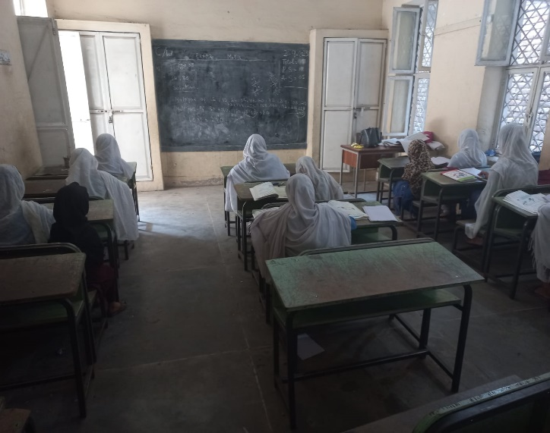GGPC Daag Behsud is facing a similar issue as mentioned above. The total enrollment for the morning shift is 933 students, whereas the enrollment for the second shift is only 28, which does not meet the standard criteria.
* According to feedback from the Head Teacher, parents are discouraging their children from attending the second shift due to dissatisfaction with the double shift timings. She also mentioned that the second shifts timing clashes with the children’s madrassa schedules. This issue had been previously discussed with the villagers and the village chairman, resulting in an agreement that the principal would not compel any student to attend the second shift. The said issue needs to be addressed again.

**Figure 2 Class strength in DSS**

**School Wise Findings**

1. **GGPS Akbar Pura EMIS Code: 20418**

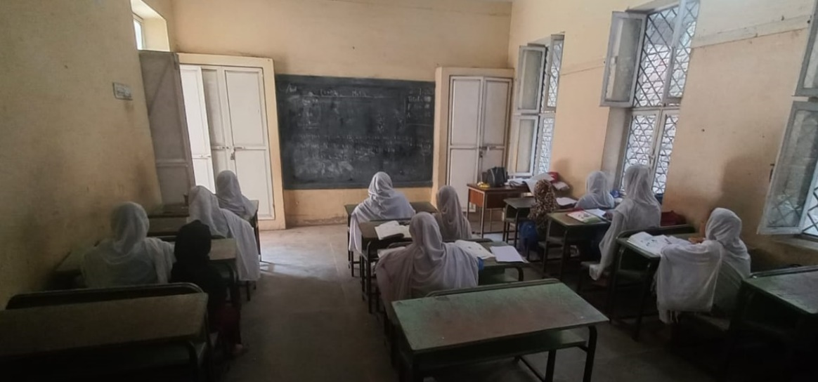

**Figure 3 View of enrollment in Double Shift School**

* The school morning shift is overcrowded, with a total enrollment of 562 students. This exceeds the available capacity as there are only eight classrooms. The enrollment is exceeding the capacity for each class and in total, which deviates from the agreed standard criteria.
* The school is functional and has all the required basic facilities for the students.
* All the classes have less than 20 students enrolled, which doesn’t meet the required criteria.

|  |  |  |  |
| --- | --- | --- | --- |
| **Morning Enrollment** | | **Second Shift Enrollment** | |
|  |  | Nursery | 16 |
| KG | 55 | KG | 12 |
| 1st | 130 | 1st | 12 |
| 2nd | 81 | 2nd | 22 (06 regular) |
| 3rd | 59 | 3rd | 12 (04 regular) |
| 4rth | 100 | 4rth | 00 |
| 5th | 102 | 5th | 20 (15 regular) |

* 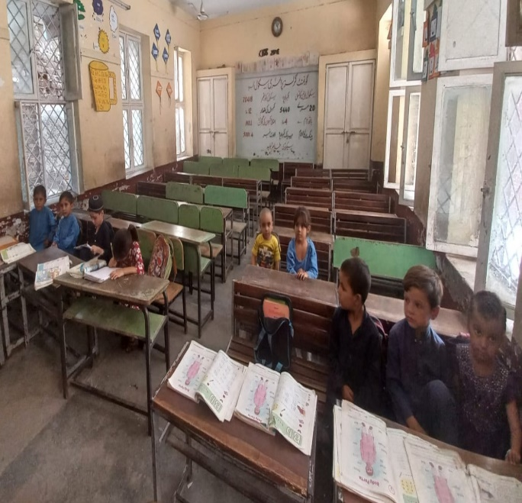During the visit, the attendance of teachers along with the students enrolled is checked.
* In the second shift, there are 22 students registered in 2nd standard, but only 06 students are attending classes. For the 3rd standard, out of 12 registered students, only 04 are attending classes in the second shift. In the 5th class, 15 out of 20 registered students are attending classes regularly in second shift. Upon feedback from teachers, they shared that a large proportion of students registered for the second shift attend classes in the morning shift.

**Figure 4 Class view in DSS**

* Four teachers are operating the school, managing the multi-grade system as only three classes were available for the second shift.
* Offer letters as well as salaries disbursed to the DSS staff are also verified.

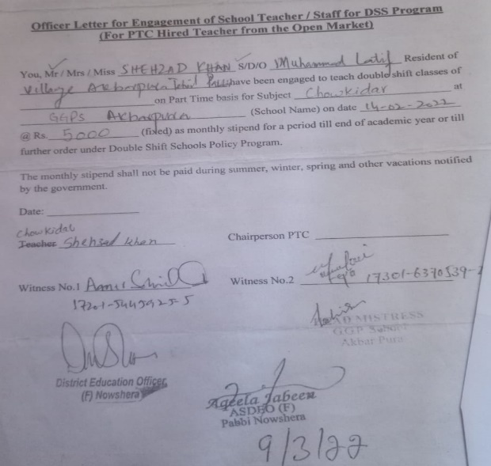

**Figure 5 Engagement/Offer letters of DSS Staff**

**Figure 6 Attendance Register of DSS**

**Figure 7 GGPS Akbarpura**

1. **GGPS Daag behsud EMIS Code: 20454**

* The total enrollment for the morning shift is 933 students, whereas the enrollment for the second shift is only 28, which does not meet the standard criteria.

|  |  |  |  |
| --- | --- | --- | --- |
| **Morning Enrollment** | | **Second Shift Enrollment** | |
| KG | 146 | KG | 13 |
| 1st grade | 127 | 1st grade | 08 |
| 2nd grade | 154 | 2nd grade | 03 |
| 3rd grade | 150 | 3rd grade | 05 |
| 4rth grade | 151 | 4rth grade | 09 |
| 5th grade | 158 | 5th grade | 00 |

* All the classes have less than 20 students despite the requirement that each class have at least 20 students.
* The school is functional and has all the basic facilities for the students.
* The total number of teachers, student’s enrollment along with attendance registers, as well as offer letters and payment disbursement to teachers is also validated.
* 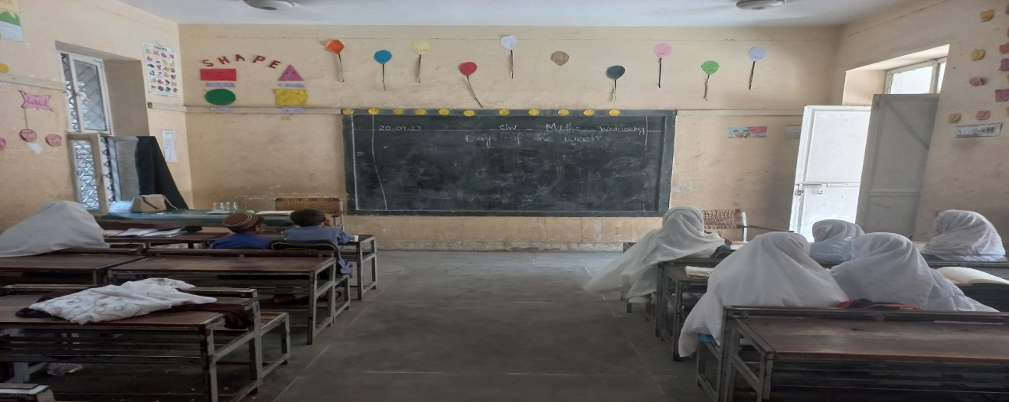According to feedback from the Head Teacher, parents are discouraging their children from attending the second shift due to dissatisfaction with the double shift timings. She also mentioned that the second shifts timing clashes with the children’s madrassa schedules. This issue had been previously discussed with the villagers and the village chairman, resulting in an agreement that the principal would not compel any student to attend the second shift. The said issue needs to be addressed again.

**Figure 8 View of class in DSS Daagbehsud**

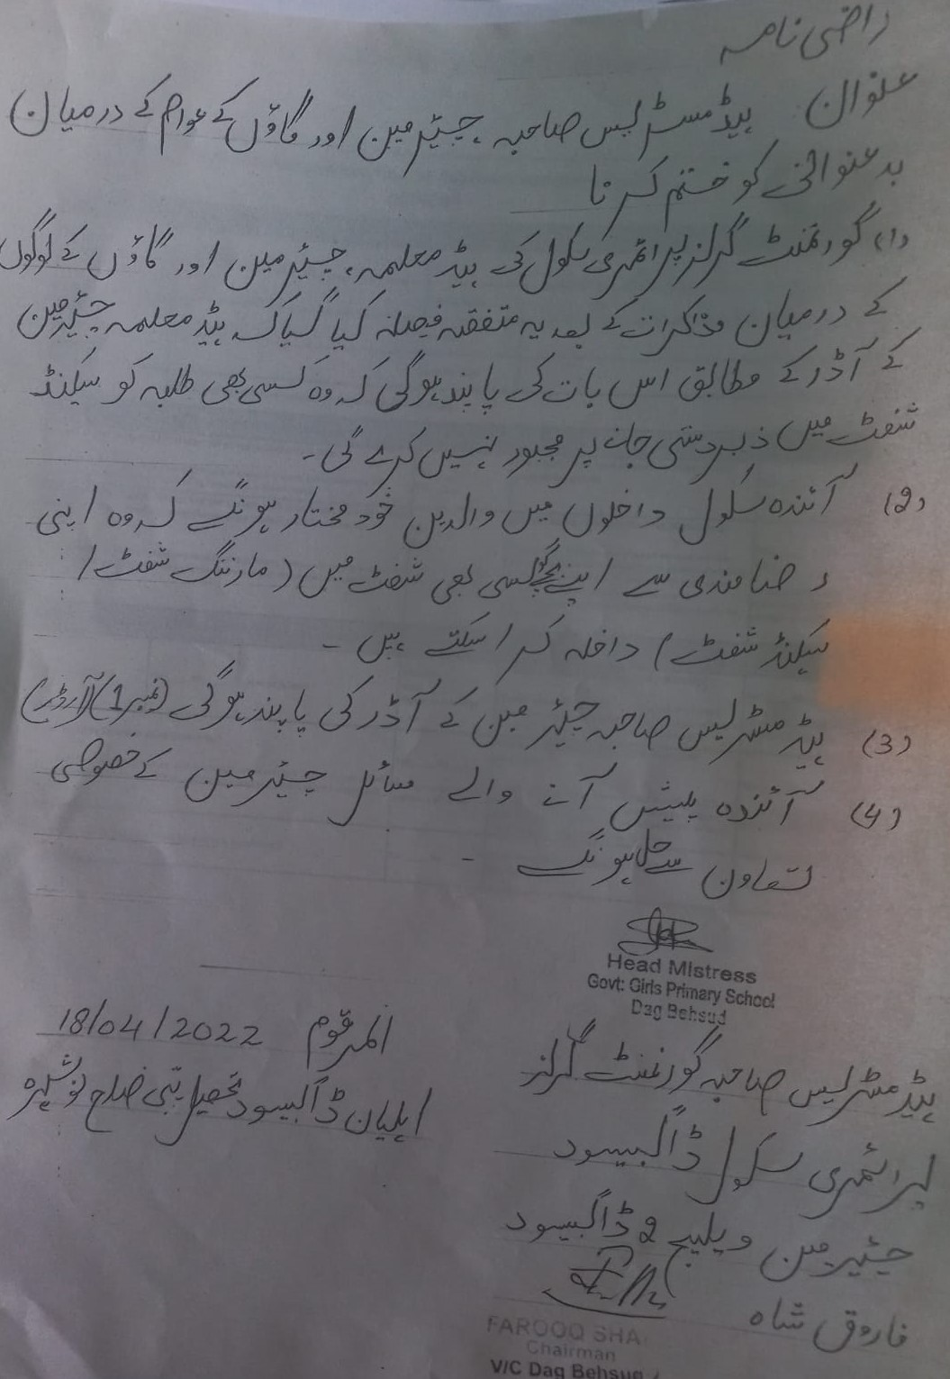

**Figure 9 Agreement with the Villagers and Village Chairman**